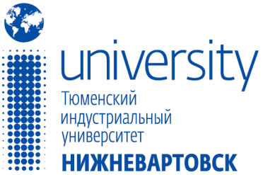 | Call for Papers  Dear colleagues! | Russian Science Citation Index
The 17th International Conference

“Innovative processes in science and technology of the XXI century”

held by the Department of Humanities, Economics and natural Sciences
Industrial University of Tyumen, Branch in Nizhnevartovsk, Russia
26-27 April, 2019

Full paper Submission deadline: 12 April, 2019

Conference Themes

      - Linguistics.
- Economics and management
- History, law, political science.
- Philosophy, sociology, cultural studies.
- Physics, mathematics, computer science.
- Chemistry, ecology, life safety.
- Technical science.

Conference Committee: PhD, Associate Professor Marina Shalaeva
PhD, Associate Professor Tatiana Gladkikh

Virtual Presentation: Please note that a virtual presentation does not mean you are able to present remotely (e.g. Internet streaming or teleconferencing)

Contacts for Manuscripts Submission: e-mail: konf.nv-tsogu@yandex.ru
Phone: +7(3466) 31-20-83

Working languages of the conference: Russian & English

Conference participants are welcome to submit full papers (max. of 3000 words), short papers (max. of 1500 words), extended abstracts, paper drafts, or invited session proposals. Submitted papers will be fully refereed and published in electronic and book formats.

Papers will be evaluated for originality, significance, clarity, and contribution. Conference proceedings will be published as a book and will be sent after the conference to indexing at Russian Science Citation Index (RSCI).

After publishing the Proceedings of the Conference will be posted on the website https://www.tyuiu.ru/branches/nizhnevartovsk/nauchnye-raboty/

Appendix 1
APPLICATION FORM
First Name, Second (Family) Name
Affiliation
Research Supervisor
Attending/Virtual participation
Conference Theme
The Title of your paper
Contact information

Appendix 2

Formatting guidelines for the manuscripts:
All papers must be formatted for A4 paper-One Column. All papers must be submitted in Microsoft Word format, 14-pt Times New Roman. Paragraph indention: 1.25 cm
Margins for the whole paper:
Top Margins: 20 mm
Bottom Margins: 30 mm
Left and Right Margins: 25 mm

Sample formatting:

Johnson В., Senior Lecture
The Arctic University of Norway, Tromsø

THE ECOLOGICAL CONDITION OF GEOLOGICAL ENVIRONMENT OF THE CITY OF TROMSØ

Abstract:
Up to 150 words in Times New Roman, 12 pt…
Key words:
3-4 terms in Times New Roman, 12 pt…

Text of the article in Times New Roman, 14 pt… [1, p.3].
…

REFERENCES
1. Second Name, A., The Title of the book. – City : Publisher, year. – 542 p.
…

Author: Johnson В., Senior Lecture, JohnsonB@gmail.com
Research supervisor*: Steven Arthur Pinker, PhD, professor of Harvard University.

* optional

